**Exercise 4: Employee Management System**

public class Main {

    public static void main(String[] args) {

        EmployeeManager manager = new EmployeeManager(5);

        manager.addEmployee(new Employee("E001", "Arun", "Developer", 50000));

        manager.addEmployee(new Employee("E002", "Banu", "Tester", 40000));

        manager.addEmployee(new Employee("E003", "Charan", "Manager", 60000));

        System.out.println("All Employees:");

        manager.traverseEmployees();

        System.out.println("\nSearch Employee E002:");

        Employee found = manager.searchEmployee("E002");

        System.out.println(found != null ? found : "Not Found");

        System.out.println("\nDelete Employee E001:");

        manager.deleteEmployee("E001");

        System.out.println("\nAll Employees After Deletion:");

        manager.traverseEmployees();

    }

}

class Employee {

    String employeeId;

    String name;

    String position;

    double salary;

    public Employee(String employeeId, String name, String position, double salary) {

        this.employeeId = employeeId;

        this.name = name;

        this.position = position;

        this.salary = salary;

    }

    public String toString() {

        return "[" + employeeId + "] " + name + " - " + position + " - ₹" + salary;

    }

}

class EmployeeManager {

    private Employee[] employees;

    private int count;

    public EmployeeManager(int size) {

        employees = new Employee[size];

        count = 0;

    }

    public void addEmployee(Employee emp) {

        if (count < employees.length) {

            employees[count++] = emp;

            System.out.println("Employee added: " + emp.employeeId);

        } else {

            System.out.println("Employee list full!");

        }

    }

    public Employee searchEmployee(String id) {

        for (int i = 0; i < count; i++) {

            if (employees[i].employeeId.equals(id)) {

                return employees[i];

            }

        }

        return null;

    }

    public void traverseEmployees() {

        for (int i = 0; i < count; i++) {

            System.out.println(employees[i]);

        }

    }

    public void deleteEmployee(String id) {

        for (int i = 0; i < count; i++) {

            if (employees[i].employeeId.equals(id)) {

                for (int j = i; j < count - 1; j++) {

                    employees[j] = employees[j + 1];

                }

                employees[--count] = null;

                System.out.println("Deleted employee: " + id);

                return;

            }

        }

        System.out.println("Employee not found: " + id);

    }

}

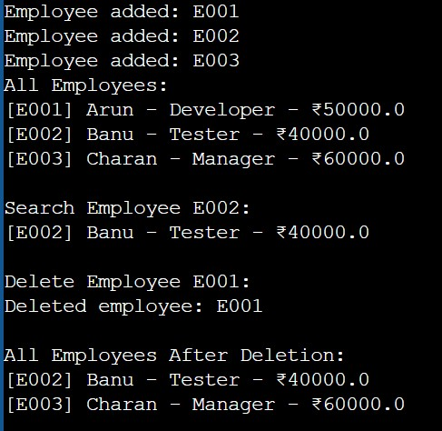Output: